The Making of Makerspaces

IDCEC: #CEU-107035
1 CEU-IDCEC Credit
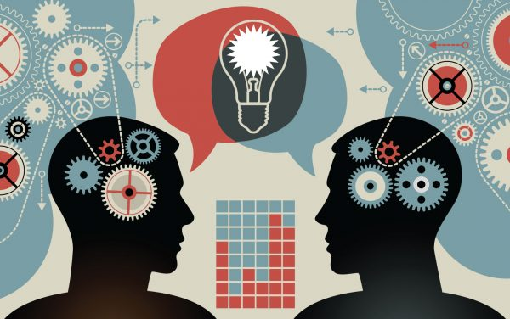

This hour-long session looks at the evolution of makerspaces and its impact on today’s society. From business to libraries and everything in-between, makerspaces have made their impact known and continue to pop-up more and more as time goes by. Explore real life examples of the positive impact these environments are cultivating and how it is leading a movement in inspiring and encouraging more creative thinkers across the globe.

